**Name: Adithya Chandrashekar**

**ID: 1000990558**

**Development Environment**

Python 2.7

Language: Python

**Program compilation:**

1. Open command prompt and reach the folder in which program is there
2. Type code <filename.py> and <IP> Eg. Proxyserver.py 127.0.0.1
3. Once this is done, open the browser and type the URL.

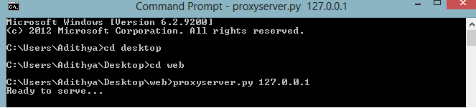



**Code reference**

J. Kurose and K. Ross, “*Computer Networking: A Top-Down Approach*,” 6th edition,

chapter 2, section 2.2, 2.7: HTTP message format, Web caching, and Socket

programming.